~Website Planning & Documentation~

Website link: https://lefikalets.github.io/WMD-Assignment/

**Introduction**

I have a task at hand which is to make a website for a movie theatre. UrJoy is the name of the website since it is also the name of the movie theatre. The intention as a web developer is to make a website that shows movies offered by the theatre, times the movies are played, and the description or plot of the movies offered. The website will help to keep customers connected to the theatre in the sense of information and communication between customers and the theatre. It I also a way of maintaining good customer service.

**Website Specifications**

* Objective and Role- The role of this website is to keep customers close to information about the movies they love that we offer. The goal is to provide dates, times, descriptive about both old and new movies. Another one of its roles is to make sure that customers have almost all the answers they need concerning anything related to the movies we offer. The objective is to interact with customers, listen to their needs in order to make sure that they receive the services they desire, and their hearts are content.
* Target Audience- Our target audience is any person who loves movies. Majority of the audience are people between the ages of 11 and 40 as according to statics they are the ones who are most interested in movies. Regardless of the age group, anyone of any age is welcome as our movies vary with age and all ages are included. We also offer different movie genres as the audience’s taste in movies vary both according to age and gender.
* Type Of Website- This website is an Information website for a Movie Theatre . It provides information like the location of the theatre and the movies offered by the theatre as well as the times the movies are played at the theatre.

**Information and Design Taxonomy**

* Sitemap

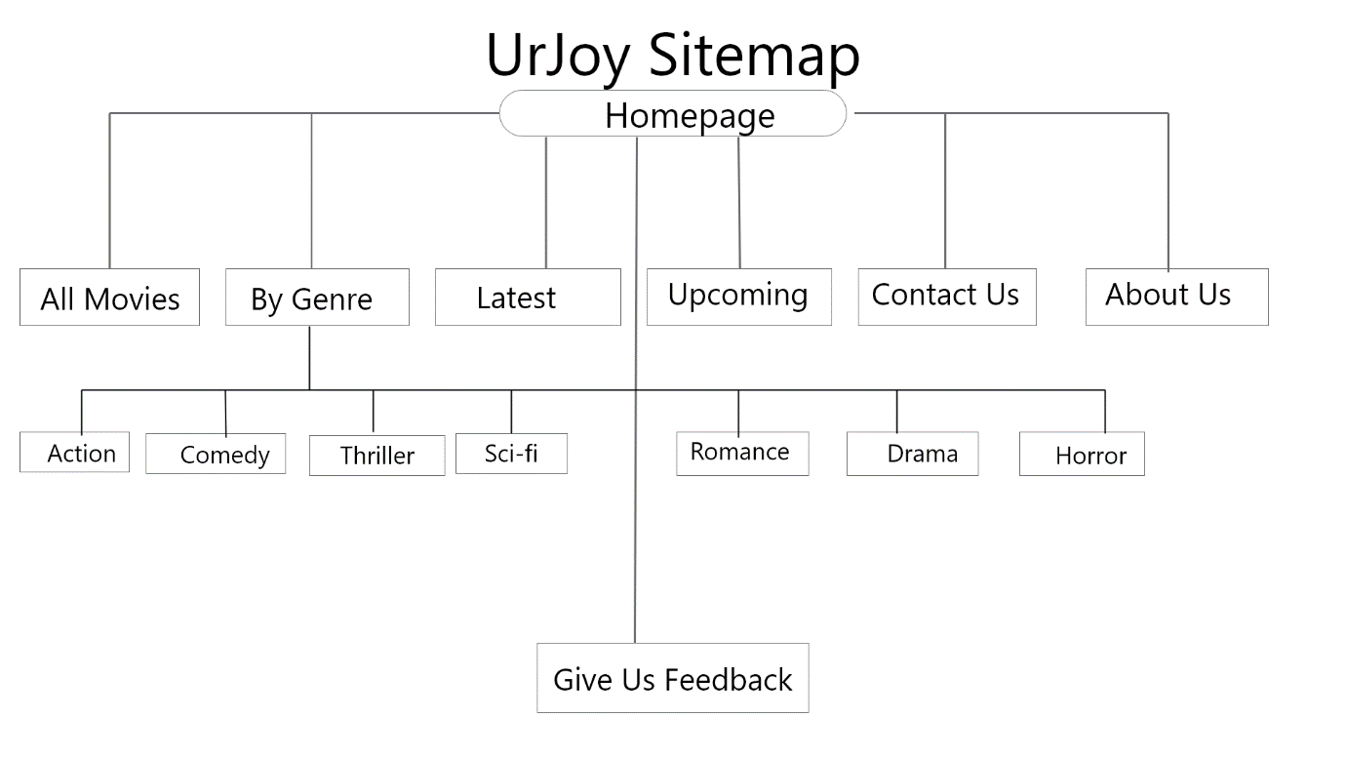

**Page Template Design**

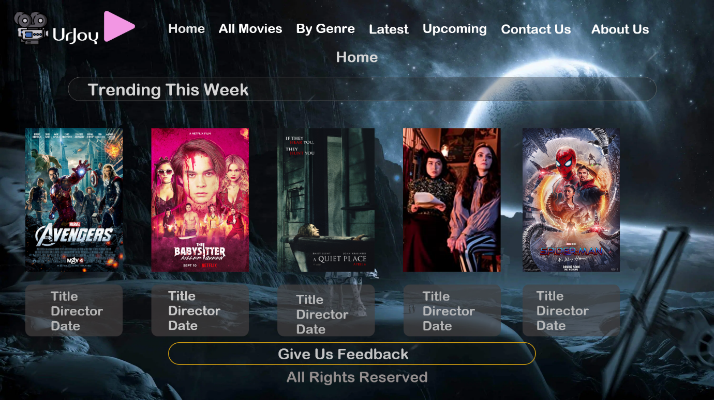

**Technical Brief**

The website is to be developed using a laptop. The software used to develop this website are, Visual Studio Code which will be used to code the HTML,CSS and JavaScript that build the website and give if visibility and functionality.

**Quality Assurance**

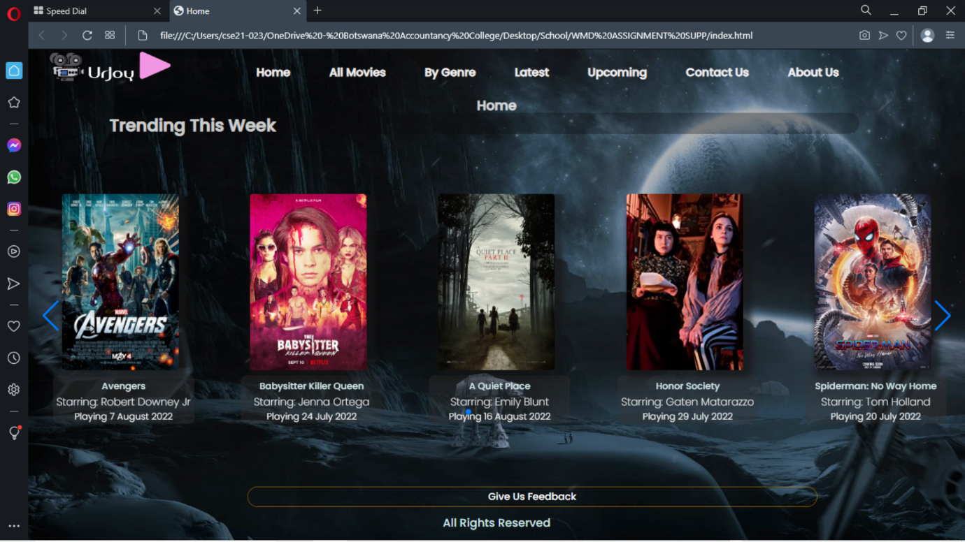

The above screenshot shows the website displaying on Opera Browser.

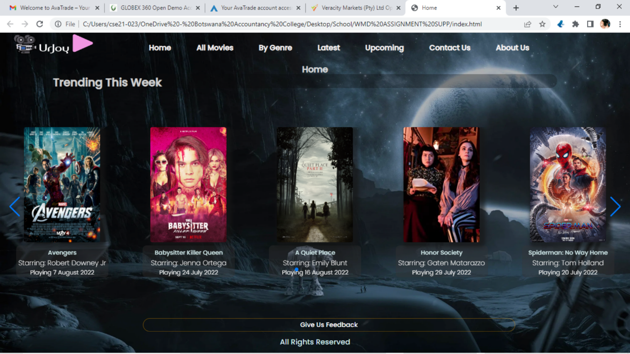

The above screenshot shows the website displaying on Brave Browser.



The above screenshot shows the website displaying on Chrome Browser.

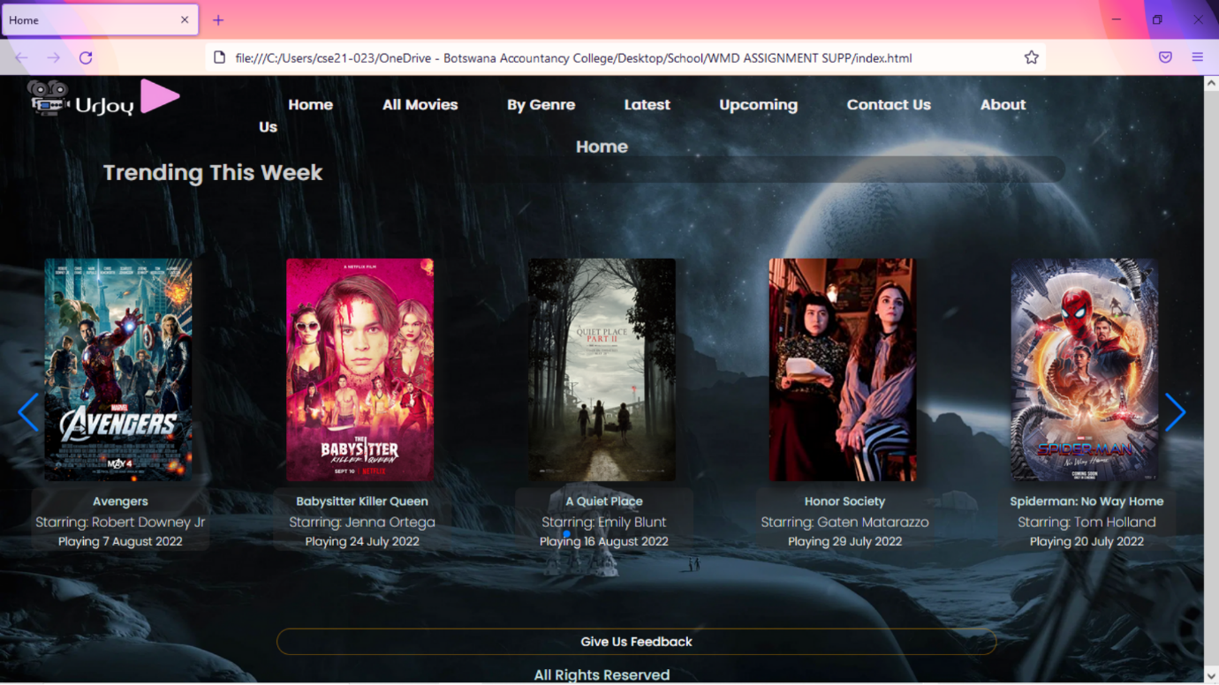

The above screenshot shows the website displaying on Mozilla Firefox Browser.

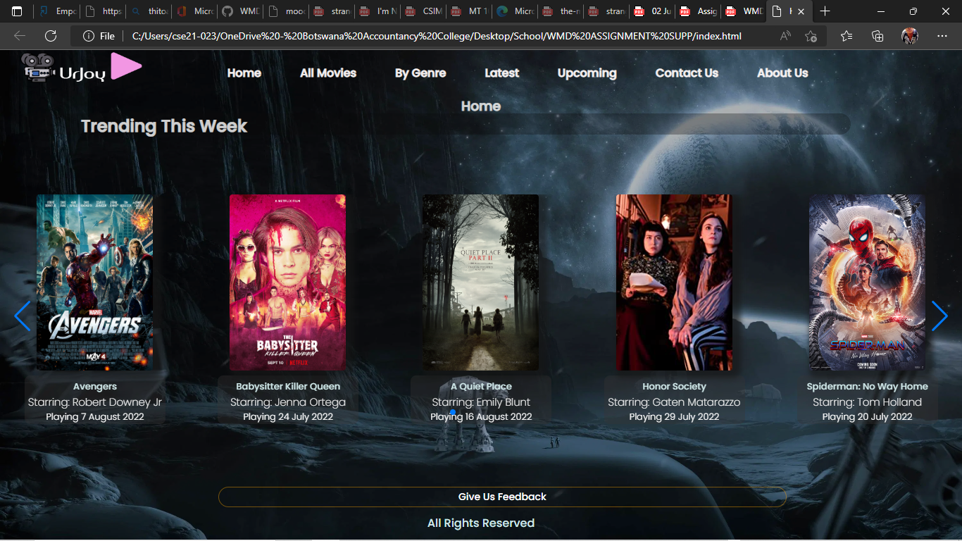

The above screenshot shows the website displaying on Microsoft Edge Browser.

**Publishing & Promotion**

I used a hosting service platform called “GitHub” to host my website. I also used Microsoft Edge to access GitHub and upload the website files.

Below are screenshots of the hosting service as well as a screenshot of the process of uploading my website files to the hosting service.

Screenshot of GitHub on Microsoft Edge browser;

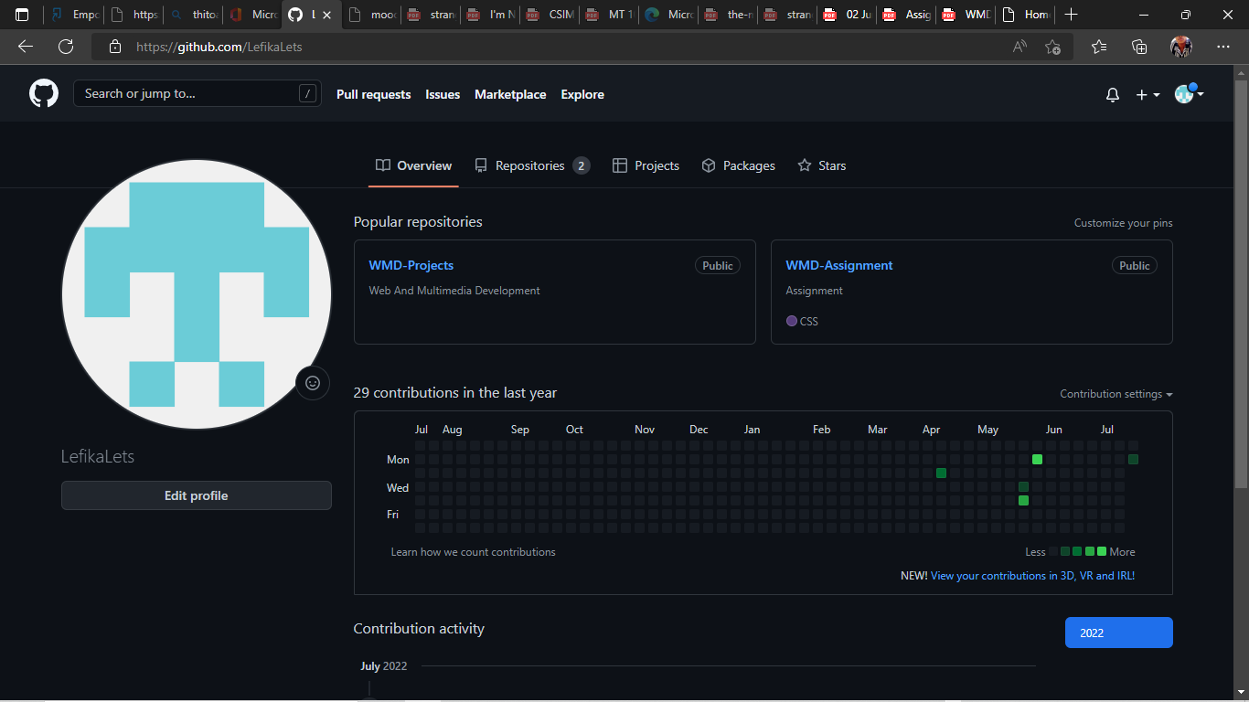

File Upload process;

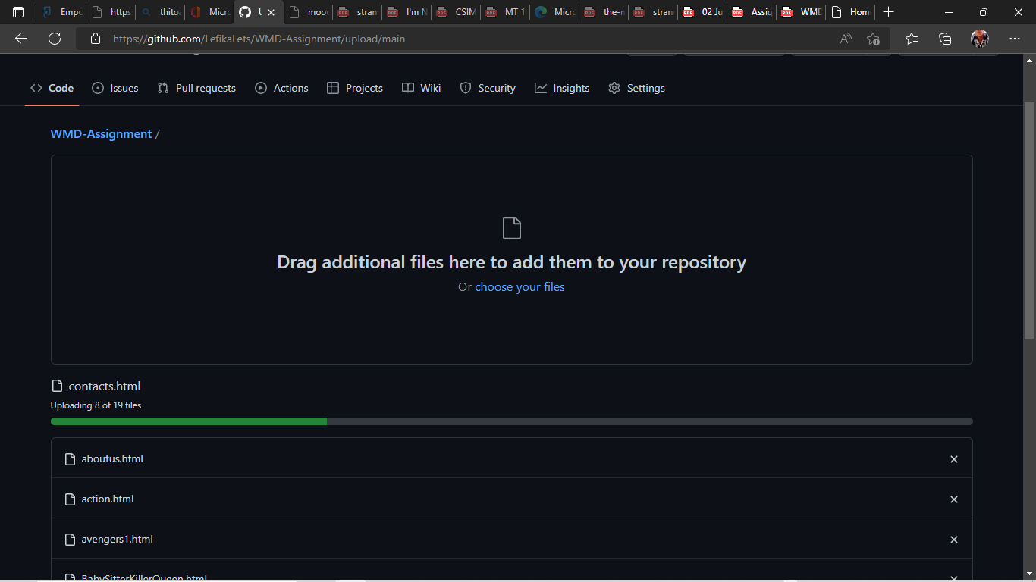

**Future Developments/Recommendations**

* In the future, improvements like ticket purchase options and movie trailers would really make a big and productive change to the website.
* Public movie ratings and customer reviews of watched movies and theatre experience would really brighten up the website and provide a sense of safety and comfort to customers.
* Promotional contests and interaction exercises could also help the website to keep the customers engaged.

Assignment link: https://lefikalets.github.io/WMD-Assignment/